***Capacitive Reactance***

**LAB # 2**



**Spring 2021**

**CSE-103L Circuit & Systems-II Lab**

Submitted by: **Maaz Habib**

Registration No.: 20PWCSE1952

Class Section: **c**

Submitted to:

**Engineer Faiz Ullah**

11th Nov, 2021

Department of Computer Systems Engineering

University of Engineering and Technology, Peshawar

**Experiment # 2**

***Capacitive Reactance***

**Objective:**

**Capacitive reactance will be examined in this exercise**. In particular, its relationship to capacitance and frequency will be investigated.

**Theory Overview:**

Resistors show a constant resistance value over a wide range of frequencies, the equivalent ohmic value for a capacitor, known as capacitive reactance, is inversely proportional to frequency. The magnitude of capacitive reactance may be determined experimentally by feeding a capacitor a known current, measuring the resulting voltage, and dividing the two, following Ohm’s Law. This process may be repeated across a range of frequencies in order to obtain a plot of capacitive reactance versus frequency.

**Equipment**

1. AC Function Generator

2. Oscilloscope

3. connecting wires

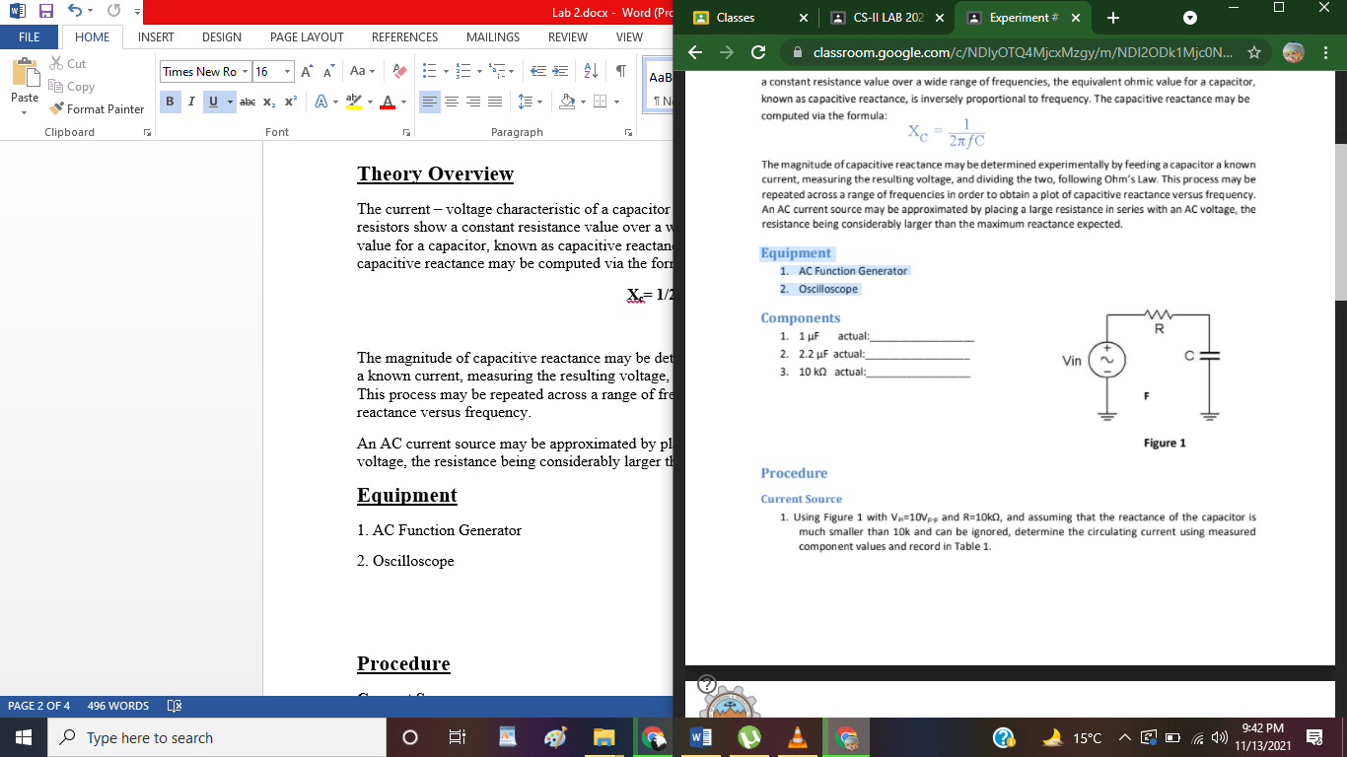**Procedure**

**Current Source**

**1.** Using Figure 1 with **Vin=10Vp-p** and **R=10kΩ,** and assuming that the reactance of the capacitor is much smaller than 10k and can be ignored, determine the circulating current using measured component values and record in Table 1.

**2**. Build the circuit of Figure 1 using **R=10kΩ,** and **C=1 μF.** Place one probe across the generator and another across the capacitor. Set the generator to a **200 Hz** sine wave and **10Vp-p.** This will reduce the signal noise and make for more accurate readings.

**3.** Calculate the theoretical value of **Xc** using the measured capacitor value and record in Table 2.

4. Record the peak-to-peak capacitor voltage and record in Table 2.

5. Using the source current from Table 1 and the measured capacitor voltage, determine the experimental reactance and record it in Table 2.

6. Repeat steps three through five for the remaining frequencies of Table 2.

7. Replace the 1 μF capacitor with the 2.2 μF unit and repeat steps two through six, recording results in Table 3.

8.Using the data of Tables 2 and 3, create plots of capacitive reactance versus frequency.

|  |  |
| --- | --- |
| ***i*source (p-p)** | 1 mA |

Table 1 (Through Ohm’s Law)

**Experimental results:**

C = 1 µF

|  |  |  |  |  |
| --- | --- | --- | --- | --- |
| Frequency | Xc = Vc/isource  (Theory) | Vc(p-p) Experimental | Xc(p-p) = 1/2πfC Experimental | % Deviation |
| 200 | 800 ohm | 0.8 V | 795.7 ohm | 0.5375 |
| 400 | 400 ohm | 0.4 V | 397.88 ohm | 0.53 |
| 600 | 300 ohm | 0.3 V | 265.25 ohm | 55.79 |
| 800 | 200 ohm | 0.2 V | 198.94 ohm | 75.1325 |
| 1.0 k | 100 ohm | 0.1 V | 159.15 ohm | -5.915 |
| 1.2 k | 10 ohm | 0.01 V | 132.62 ohm | -10.21 |
| 1.6 k | 20 ohm | 0.02 V | 99.47 ohm | -4.966 |
| 2.0 k | 30 ohm | 0.03 V | 79.57 ohm | -2.47 |

Table 2

C = 2.2 µF

|  |  |  |  |  |
| --- | --- | --- | --- | --- |
| Frequency | Xc Theory | Vc(p-p) [Scale = 0.5]  Experimental | Xc(p-p) Experimental | % Deviation |
| 200 | 6000 ohm | 6 V | 361.71 ohm | 93.97 |
| 400 | 6000 ohm | 6 V | 180.85 ohm | 96.98 |
| 600 | 6000 ohm | 6 V | 120.57 ohm | 97.99 |
| 800 | 6000 ohm | 6 V | 90.42 ohm | 98.49 |
| 1.0 k | 6000 ohm | 6 V | 72.34 ohm | 98.79 |
| 1.2 k | 6000 ohm | 6 V | 60.28 ohm | 98.99 |
| 1.6 k | 6000 ohm | 6 V | 45.21 ohm | 99.24 |
| 2.0 k | 6000 ohm | 6 V | 36.17 ohm | 99.39 |

Table 3

**Questions:**

1. **What is the relationship between capacitive reactance and frequency?**

**Answer:** It is inversely proportional to each other. As the formula shows by itself:

**Xc= 1/2πfC**

**Xc = 1/f**

**Where;**

Xc = Capacitive reactance

f = frequency.

1. **What is the relationship between capacitive reactance and capacitance?**

**Answer:** It is inversely proportional to each other;

**Xc= 1/2πfC**

**Xc = 1/C**

Where;

Xc = Capacitive reactance

C = capacitance.

1. **If the experiment had been repeated with frequencies 10 times higher than those in Table 2, what would the resulting plots look like?**

**Answer:** The impedance value would have been decreasing exponentially as the above table already shows the value of impedance either it is theoretical or experimental.

1. **If the experiment had been repeated with frequencies 10 times lower than that in Table 2, what effect would that have on the experiment?**

**Answer:** The impedance value would been increasing exponentially as the above table already shows the value of impedance either it is theoretical or experimental in the starting data where the frequency is lower than the others.

**Procedure:**

1. Set the circuit, with the help of proteus.

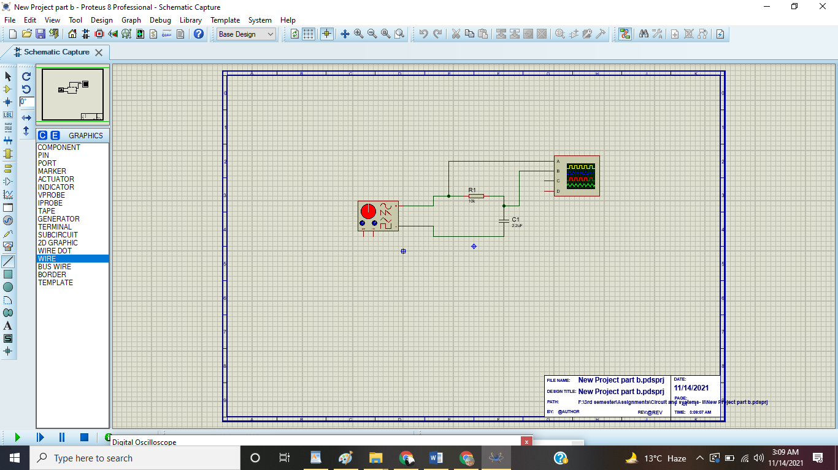

1. Run the simulation, to check and make starting point.

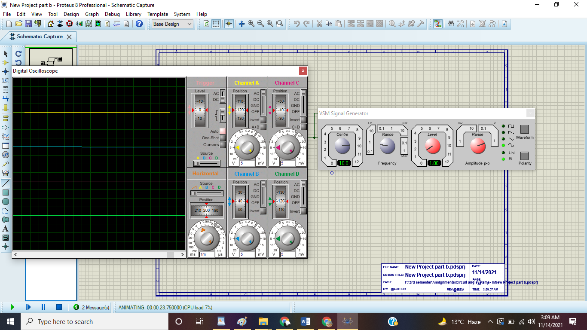

1. Set the amplitude and level of the function generator. Multiply the values as it will give the peak-to-peak voltage. Also. Similarly, set the range and center at the frequency section.

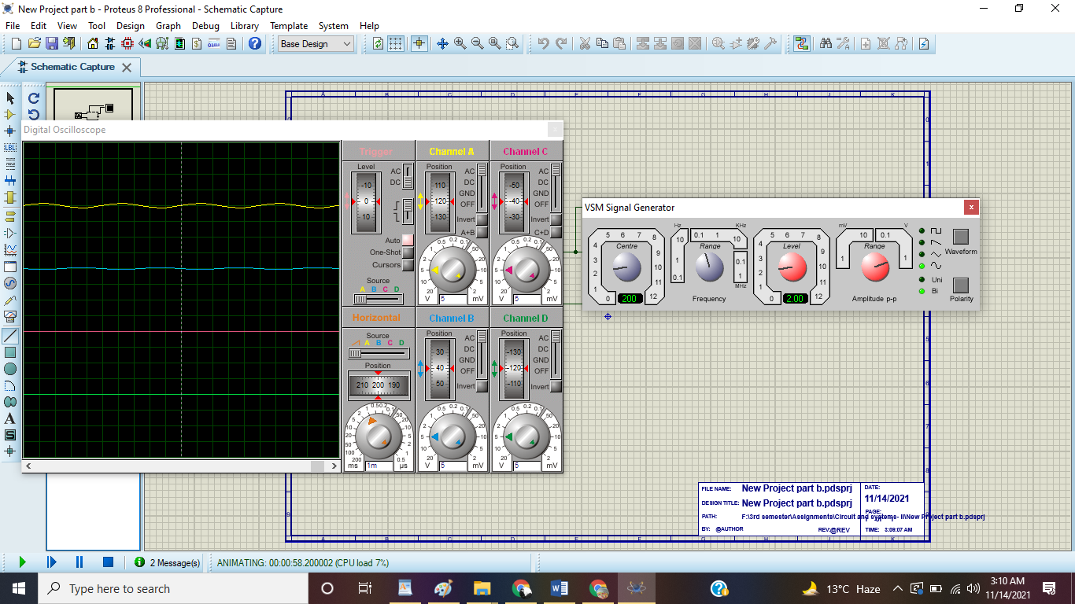

1. Turn off Channel C and Channel D.

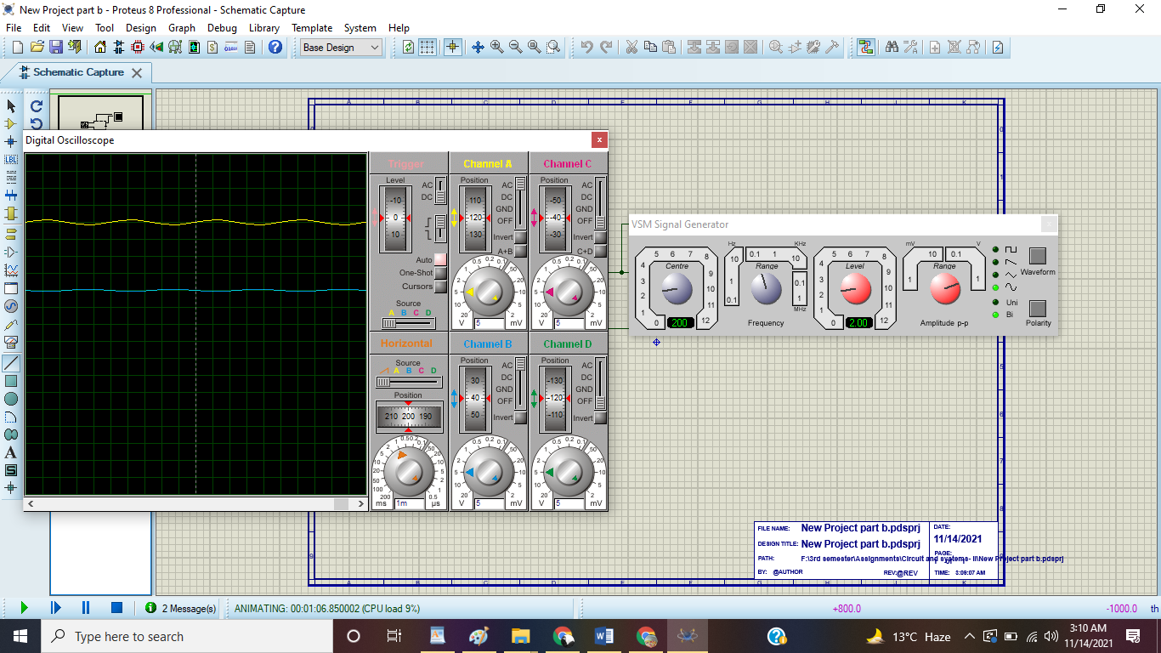

1. Bring Channel A and Channel B to the center position.

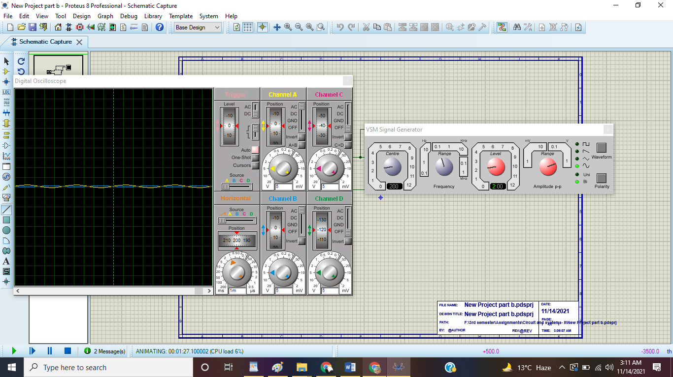

1. Set the scale division of the channel B and count the division of its graph vertically. Multiply both of them as it will give the Capacitor’s voltage.

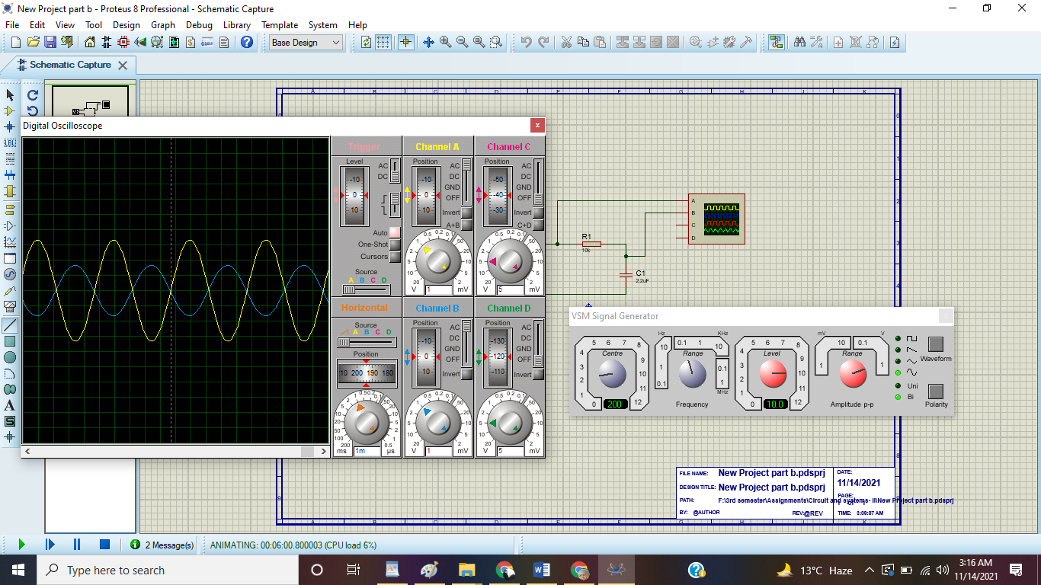

1. For theoretical capacitive reactance, use ohm’s law which is Xc= Vc/Isource .
2. For experimental capacitive reactance, use the following formula; **Xc= 1/2πfC**
3. Use the deviation formula, calculate the difference between the theoretical and experimental values.